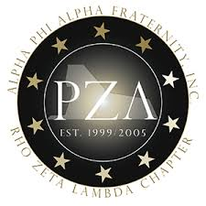  
**The official Organ of Alpha Phi Alpha Fraternity, Inc. Rho Zeta Lambda Chapter**

**The Phoenix**

**FRATERNAL YEAR KICKOFF**

Brothers gather in support of Speaker Bro. Emanuel “Chris” Welch 9th annual Back to School Health Fair on July 31, 2021 at Proviso West High School. Alpha Phi Alpha Fraternity, Inc. Rho Zeta Lambda Chapter, serves as a partner for this annual event that provides health, wellness, school supplies and other community support for children preparing for the new school year.

**L to R** Bro. Corey Bullock, Bro. Kyle Wideman, Bro. Henry Norris, Bro. Arthur Cotman, Bro. Jeremiah Bundy, Bro. Azreal Muhammad. **Below** – Bro Hernandez, Bro. Henry Norris

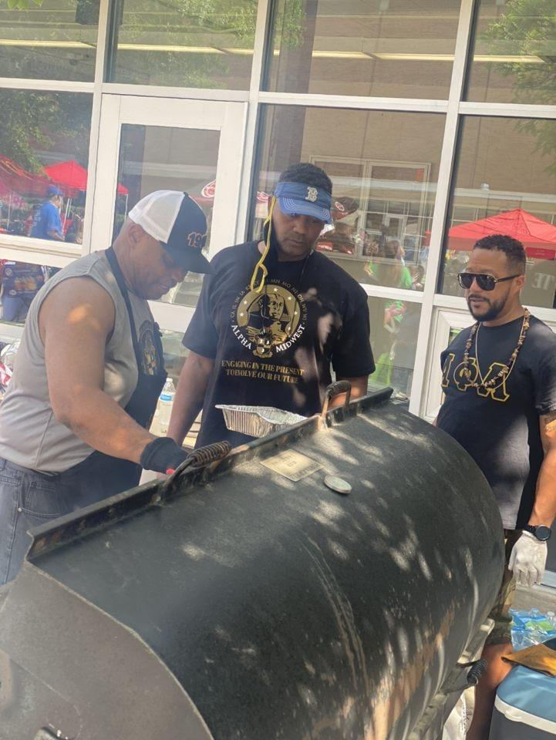Bro. Geoff Bradley Bey, Bro. Henry Norris

Bro. Wonderful Watson, Bro. Arthur Cotman, Bro. Jeremiah Bundy

**ΡΖΛ**

**CHAPTER BOOK CLUB AND FELLOWSHIP**

The pandemic has placed barriers in all forms of physical and social interaction. Throughout the past year, we have witnessed the cancellation of numerous fraternal events that brings out that spirit of brotherhood we all endear. The chapter book club has been pivotal in keeping the brotherhood spirit alive during these rough times. The chapter book club meets monthly at a location chosen by the host of the event. The book club offers intellectual dialogue, food, beverage, and fun.

Bro. G. Bradley-Bey, Bro. C. Bullock, Bro. A. Cotman, Bro. I. Jones, Bro. A. Muhammad, Bro. J. Bundy

Bro. Charles Colston, Bro. Corey Bullock, Bro. Jeremiah Bundy

**ALPHA QUEST YOUTH MENTORING PROGRAM 2020-2021 KICKOFF**

Robotics Programing Event September 25, 2021

**ΡΖΛ**

**2021-2022 AQYMP PROGRAM SCHEDULE**

**9/11/21 *Information with students and parents***

**9/18/2021 *Robotics Programing***

**10/16/2021 *DuSable Museum Field Trip***

**11/6/2021 *Project Alpha (Location TBA)***

**12/18/2021 *Game of Life Financial Simulation***

**1/15/2022 *College Life & Career Exploration* Guest Speakers**

**2/19/2022 *Stock Market Investment Simulation Game***

**3/19/2022 *Physical & Mental Health Session Mindfulness/Meditation***

**4/9/22 *Delta Sigma Theta, Glynn Ellyn Chapter EMBODI program***

**5/21/2022 *Open Gym Game Day***

**6/18/22 *Alpha Quest Closeout Ceremony***

**July/August 2022 *Leadership Development Institute (LDI) Preparation***